February 25, 2019

Professor Meg Daly
Chair, Arts and Sciences Curriculum Committee

Re: Approval of Revision for BA in Arabic, Arabic minor

Dear Meg,

The Arts & Humanities Panel 1 of the ASCC approved a proposed revision from the Department of Near Eastern Languages and Cultures (NELC) regarding the Arabic major. The proposal was originally reviewed on November 6, 2018 and sent back with a list of questions and suggestions. We received the second revision in January 2019, and after review the BA major revision was officially approved on February 5, 2019 by our panel. In addition, we also reviewed a proposed revision to the Arabic minor, which followed a similar trajectory before being approved on February 5, 2019.
The BA revision was based on benchmarking peer institutions, suggestions from external reviewers, and student feedback regrading difficulties completing the major sequence, and faculty resources. The BA revision proposes the following: Allow students to specialize in Modern Standard, Colloquial or Media Arabic; and modify prerequisites by moving the required course in Arabic Literature and Culture in Translation from a prerequisite to a required course for the major and minor. This allows students to immediately begin working on major or minor courses, even while they may be taking the introductory language sequence prerequisite. The revision also included new student learning objectives, new assessment strategies, and a transition plan to clarify how students move through major. Newly declared majors will be required to follow the new program plan as of Autumn 2019.

The panel agreed that the proposed BA revision, as articulated, offers a range options for students and for faculty who teach in the major. The BA revision was unanimously approved by our committee with two contingencies, which have been resolved, while the minor was unanimously approved with no contingencies. We now advance the major and minor proposals to the Arts and Sciences Curriculum Committee with a motion to approve.

Best,
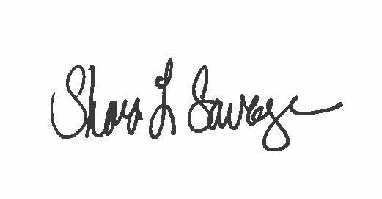

Shari L. Savage, PhD
Associate Professor
Undergraduate Education, Teaching & Assessment Chair
savage.12@osu.edu

